Top of Form

A Brief History of Microbiology
Microbiology has had a long, rich history, initially centered in the causes of infectious diseases but now including practical applications of the science. Many individuals have made significant contributions to the development of microbiology.
Early history of microbiology. Historians are unsure who made the first observations of microorganisms, but the microscope was available during the mid‐1600s, and an English scientist named Robert Hooke made key observations. He is reputed to have observed strands of fungi among the specimens of cells he viewed. In the 1670s and the decades thereafter, a Dutch merchant named Anton van Leeuwenhoek made careful observations of microscopic organisms, which he called animalcules. Until his death in 1723, van Leeuwenhoek revealed the microscopic world to scientists of the day and is regarded as one of the first to provide accurate descriptions of protozoa, fungi, and bacteria.
After van Leeuwenhoek died, the study of microbiology did not develop rapidly because microscopes were rare and the interest in microorganisms was not high. In those years, scientists debated the theory of spontaneous generation, which stated that microorganisms arise from lifeless matter such as beef broth. This theory was disputed by Francesco Redi, who showed that fly maggots do not arise from decaying meat (as others believed) if the meat is covered to prevent the entry of flies. An English cleric named John Needham advanced spontaneous generation, but Lazzaro Spallanzani disputed the theory by showing that boiled broth would not give rise to microscopic forms of life.
Louis Pasteur and the germ theory. Louis Pasteur worked in the middle and late 1800s. He performed numerous experiments to discover why wine and dairy products became sour, and he found that bacteria were to blame. Pasteur called attention to the importance of microorganisms in everyday life and stirred scientists to think that if bacteria could make the wine “sick,” then perhaps they could cause human illness.
Pasteur had to disprove spontaneous generation to sustain his theory, and he therefore devised a series of swan‐necked flasks filled with broth. He left the flasks of broth open to the air, but the flasks had a curve in the neck so that microorganisms would fall into the neck, not the broth. The flasks did not become contaminated (as he predicted they would not), and Pasteur's experiments put to rest the notion of spontaneous generation. His work also encouraged the belief that microorganisms were in the air and could cause disease. Pasteur postulated the germ theory of disease, which states that microorganisms are the causes of infectious disease.
Pasteur's attempts to prove the germ theory were unsuccessful. However, the German scientist Robert Koch provided the proof by cultivating anthrax bacteria apart from any other type of organism. He then injected pure cultures of the bacilli into mice and showed that the bacilli invariably caused anthrax. The procedures used by Koch came to be known as Koch's postulates (Figure ). They provided a set of principles whereby other microorganisms could be related to other diseases.
The development of microbiology. In the late 1800s and for the first decade of the 1900s, scientists seized the opportunity to further develop the germ theory of disease as enunciated by Pasteur and proved by Koch. There emerged a Golden Age of Microbiology during which many agents of different infectious diseases were identified. Many of the etiologic agents of microbial disease were discovered during that period, leading to the ability to halt epidemics by interrupting the spread of microorganisms.
Despite the advances in microbiology, it was rarely possible to render life‐saving therapy to an infected patient. Then, after World War II, the antibiotics were introduced to medicine. The incidence of pneumonia, tuberculosis, meningitis, syphilis, and many other diseases declined with the use of antibiotics.
Work with viruses could not be effectively performed until instruments were developed to help scientists see these disease agents. In the 1940s, the electron microscope was developed and perfected. In that decade, cultivation methods for viruses were also introduced, and the knowledge of viruses developed rapidly. With the development of vaccines in the 1950s and 1960s, such viral diseases as polio, measles, mumps, and rubella came under control.
Modern microbiology. Modern microbiology reaches into many fields of human endeavor, including the development of pharmaceutical products, the use of quality‐control methods in food and dairy product production, the control of disease‐causing microorganisms in consumable waters, and the industrial applications of microorganisms. Microorganisms are used to produce vitamins, amino acids, enzymes, and growth supplements. They manufacture many foods, including fermented dairy products (sour cream, yogurt, and buttermilk), as well as other fermented foods such as pickles, sauerkraut, breads, and alcoholic beverages.
One of the major areas of applied microbiology is biotechnology. In this discipline, microorganisms are used as living factories to produce pharmaceuticals that otherwise could not be manufactured. These substances include the human hormone insulin, the antiviral substance interferon, numerous blood‐clotting factors and clotdissolving enzymes, and a number of vaccines. Bacteria can be reengineered to increase plant resistance to insects and frost, and biotechnology will represent a major application of microorganisms in the next century.
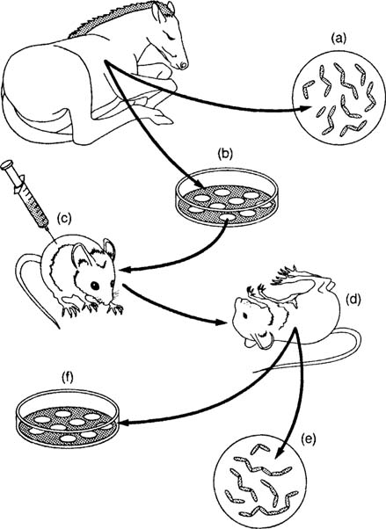
The steps of Koch's postulates used to relate a specific microorganism to a specific disease. (a) Microorganisms are observed in a sick animal and (b) cultivated in the lab. (c) The organisms are injected into a healthy animal, and (d) the animal develops the disease. (e) The organisms are observed in the sick animal and (f) reisolated in the lab.
The development of microbiology. In the late 1800s and for the first decade of the 1900s, scientists seized the opportunity to further develop the germ theory of disease as enunciated by Pasteur and proved by Koch. There emerged a Golden Age of Microbiology during which many agents of different infectious diseases were identified. Many of the etiologic agents of microbial disease were discovered during that period, leading to the ability to halt epidemics by interrupting the spread of microorganisms.
Despite the advances in microbiology, it was rarely possible to render life-saving therapy to an infected patient. Then, after World War II, the antibiotics were introduced to medicine. The incidence of pneumonia, tuberculosis, meningitis, syphilis, and many other diseases declined with the use of antibiotics.
Work with viruses could not be effectively performed until instruments were developed to help scientists see these disease agents. In the 1940s, the electron microscopewas developed and perfected. In that decade, cultivation methods for viruses were also introduced, and the knowledge of viruses developed rapidly. With the development of vaccines in the 1950s and 1960s, such viral diseases as polio, measles, mumps, and rubella came under control.

Bottom of Form

History of Microbiology Timeline
1665-Robert Hooke
- This is the year Hooke reported after observing a thin slice of cork through a crude microscope that life's smallest structural units were "cells". This discovery marked the beginning of the cell theory (all living things are composed of cells).

1673-1723-Anton van Leeuwenhoek
- Observed the first microbes in 1673, with the microscope he made. Throughout these years he wrote about the animalcules he seen through his simple single lens microscopes.

1796-Edward Jenner
- Inoculated a person with cowpox virus, who was then protected from smallpox. (Protection called Immunity.)
- Vaccination is derived from vacca for cow-Vaccinations came about.

1835-Agostino Bassi
- Showed that silkworm disease was caused by a fugus.

1840-Ignaz Semmelweis
- Advocated hand washing to prevent transmission of puerperal fever from one OB patient to another.

1857-1914-The Golden Age of Microbiology
- Rapid advances, spearheaded mainly by Pasteur and Robert Koch, led to the establishment of microbiology.
- Microbiologists studied the chemical activities of microorganisms, improved the techniques for performing microscopy and culturing microorganisms, and developed vaccines and surgical techniques.

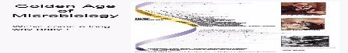
1858-Rudolf Virchow
- Challenged the case for spontaneous generation with the concept of biogenesis.
- Hypothesized that living cells arise only from preexisting living cells.

1860-Joseph Lister
- Used a chemical disinfectant to prevent surgical wound infections, based on Pasteur's work showing that microbes are in the air, can spoil food, and cause diseases. (Clean the materials that you use.)

1861-Louis Pasteur
- Disproved Spontaneous Generation.
- Demonstrated that microorganisms are present in the air and can contaminate sterile solutions.
- Created the S-shaped flask that kept microbes out but let air in.
- Showed microbes are responsible for fermentation (the conversion of sugar to alcohol).
- Demonstrated that these spoilage bacteria could be killed by heat that was not hot enough to evaporate the alcohol in wine-Pasterization: the application of a high heat for a short time.
- Believed that another silkworm disease was caused by a protozoan.

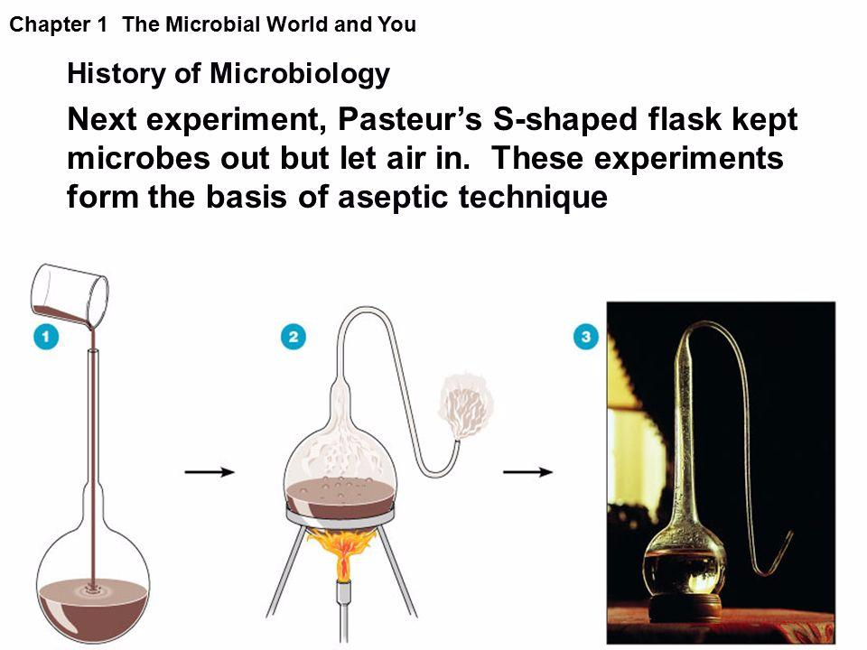

1876-Robert Koch
- Proved that bacterium causes anthrax and provided the experimental steps--Koch's Postulates to prove that a specific microbe causes a specific disease.

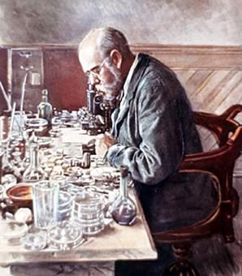
Share
1910-Paul Erlich
- Speculated about a "magic bullet" that could destroy a pathogen without harming the host
- Synthetic arsenic drug, salvarsan to treat syphilis.

1928-Alexander Fleming
- Discovered the first antibiotic, penicillium fungus killed staphylococcus aureus.
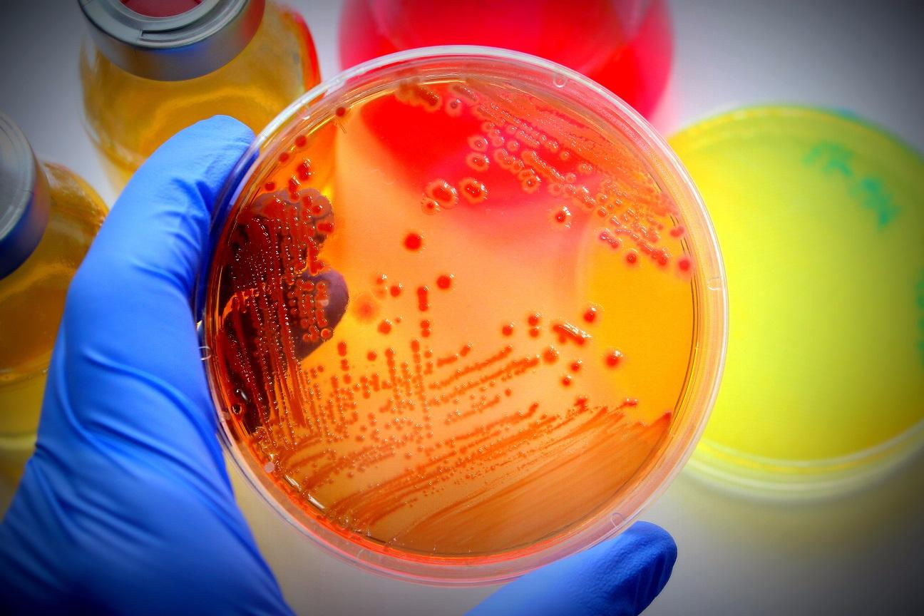
Share
1930-
- Sulfonamides were synthesized (bactrum, sulfa).

1940-
- Penicillin was tested clinically and mass produced.

